

**FACULTY OF INFORMATION TECHNOLOGY AND COMMUNICATION STUDIES**

**DEPARTMENT OF INFORMATION TECHNOLOGY STUDIES**

**UNDERGRADUATE WORK**

**DESIGN AND IMPLEMENTATION OF AN ONLINE COMPLAINT MANAGEMENT SYSTEM**

**BY**

**LAMPTEY WILLIAM N. ODARTEI ID: 10101875**

**AFRANIE GILBERT ASANTE ID: 10107998**

**JUNE 2022**



**DESIGN AND IMPLEMENTATION OF AN ONLINE COMPLAINT MANAGEMENT SYSTEM**

THIS PROJECT REPORT IS SUBMITTED TO THE DEPARTMENT OF INFORMATION TECHNOLOGY STUDIES OF THE FACULTY OF INFORMATION TECHNOLOGY AND COMMUNICATION STUDIES OF THE UNIVERSITY OF PROFESSIONAL STUDIES, ACCRA IN PARTIAL FULFILLMENT FOR A BACHELOR OF SCIENCE DEGREE IN INFORMATION TECHNOLOGY MANAGEMENT

**JUNE 2022**

# CANDIDATES’ DECLARATION

We, the undersigned do hereby declare that this dissertation is the result of our original research and that no part of it has been presented for another Degree in any University. We are convinced that this project was not copied from any other person. All sources of information have however been acknowledged with due respect.

**NAME OF STUDENT**  **INDEX SIGN DATE**

**LAMPTEY WILLIAM N. ODARTEI** **10101875 ..……………… ………………..**

**AFRANIE GILBERT ASANTE**  **10107998 ..………………. ………………..**

# 

# SUPERVISOR’S DECLARATION

I declare that the preparation and the presentation of this Dissertation were in accordance with the guidelines on supervision of Dissertation laid down by the University of Professional Studies, Accra (UPSA).

SIGN: …………………….

SUPERVISOR: DR PATRICK KUDJO

DATE: ……………………

# 

# DEDICATION

This dissertation is dedicated to God Almighty who has been of tremendous help in making this study a success. Also, to our beloved parents and benefactors for sponsoring our education and also to all UPSA teaching and non-teaching staff for their explicit support, we dedicate this work to you all.

# ACKNOWLEDGEMENTS

We extend our first gratitude to Almighty God for protecting and guiding us through the University of Professional Studies, Accra (UPSA).

To our unrelenting supervisor, Dr. Patrick Kudjo under whose guidance and supervision this research has become a success, we remain extremely grateful. We further extent gratitude to all lecturers and students whose diverse contributions have led to the successful completion of this study.

Finally, we appreciate all the contribution made by **xxxxxx** and the staff of **xxxxx** for their help during the testing and implementation of this system

**ABSTRACT**

An online management system basically makes available an online manner of solving issues faced by people by saving time and getting rid of corruption.A major objective of the online complaint management system is to make complaints more easier to bring together, monitor, follow, resolve and to make available company with a successful tool to identify specific problem areas, monitor complaints handling performance and make business advancements. Online Complaint management is a management strategy for evaluating, breaking down and responding to people or customer complaints. In this system a Complaint Management Software is used to make records, analyze and give responds to customer complaints requests and in addition make any other feedback easier. This project deals with designing and implementing an online complaint management system for the institution. In order to successfully develop the online complaint management system a few technologies need to be studied thoroughly and understood well. These include implementation technologies such as PHP, HTML, JavaScript, bootstrap, css and database( Microsoft sql server 2012). This is a project with the objective to develop an online complaint management system for the institution where it will be easier to coordinate, monitor and resolve complaints. This document will discuss the process and technologies to design and implement an online complaint system for the institution. .

Keywords: online , complaint , management , respond , customer .

**TABLE OF CONTENT**

Candidates’ Declaration............................................................................................................ 2

Supervisor’s Declaration .......................................................................................................... 3

Dedication................................................................................................................................. 4

Acknowledgement ................................................................................................................... 5

Abstract.................................................................................................................................... 6

Chapter One ........................................................................................................................... 12

General Introduction............................................................................................................... 12

1.1 Background of the Study .................................................................................... 12

1.2 Overview of the Study.........................................................................................13

1.3 Problem Statement.............................................................................................. 14

1.4 Scope of the Project ............................................................................................14

1.5 Limitation of the Study…………........................................................................14

1.6 Objective of the Study ........................................................................................15

1.6.1 General Objective of the Study ..........................................................15

1.6.2 Specific Objective of the Study ..........................................................15

1.7 Organization of the Study .................................................................................. 15

Chapter Two ......................................................................................................................... 17

Literature Review.................................................................................................................. 17

2.1 Introduction ....................................................................................................... 17

2.2 Review of the Existing System........................................................................... 18

2.2.1 Paper Based Complaint System.......................................................... 18

2.2.2 Phone Call Complaint System............................................................ 18

2.2.3 Physical Help Desk System................................................................ 18

2.2.4 Review of the Proposed System..........................................................19

2.3 Conclusion...........................................................................................................19

Chapter Three........................................................................................................................ 20

Life Cycle Design of the Current System............................................................................. 20

3.1 Introduction........................................................................................................ 20

3.2 Crystallization of the Problem........................................................................... 20

3.3 Analysis and Design of the System................................................................... 20

3.3.1 System Requirement ......................................................................... 21

3.3.2 Function Requirement....................................................................... 21

3.3.3 Non-Function Requirement……....................................................... 21

3.3.4 Hardware Requirement...................................................................... 22

3.5.5 Software Requirement....................................................................... 22

3.4 Flow Chart Diagram.......................................................................................... 23

3.4.1 Entity Relationship Diagram............................................................. 24

3.4.2 Data Flow Diagram........................................................................... 26

3.4.3 Use Case Diagram ............................................................................ 27

3.5 System Development and Tools Used................................................................. 28

Architecture of the System......................................................................................... 30

Chapter Four............................................................................................................................ 32

System Testing, Implementation and Documentation............................................................. 32

4.1 Introduction........................................................................................................... 32

4.2 Testing Done On the System................................................................................ 33

4.2.1 Unit Testing.......................................................................................... 33

4.2.2 Functional Testing................................................................................ 33

4.2.3 Usability Testing.................................................................................. 33

4.2.4 Acceptance Testing……...................................................................... 34

4.2.5 Visual Testing……….......................................................................... 34

4.3 Implementation of the New System..................................................................... 34

4.3.1 Pilot Implementation............................................................................ 34

4.3.2 Phased Implementation........................................................................ 34

4.3.3 Parallel Implementation........................................................................ 35

4.3.4 Direct Implementation......................................................................... 35

4.4 System Documentation........................................................................................ 35

4.4.1 About The System................................................................................ 36

4.4.2 User Access Level................................................................................ 37

4.4.3 Getting Started..................................................................................... 38

4.5 Conclusion........................................................................................................... 41

Chapter Five........................................................................................................................... 42

Conclusion and Recommendation......................................................................................... 42

5.1 Introduction......................................................................................................... 42

5.2 Summary............................................................................................................. 42

5.3 Recommendation................................................................................................ 43

5.4 Conclusion.......................................................................................................... 43

References............................................................................................................................. 45

I. Appendix A...........................................................................................................

Program Source Code............................................................................................

Ii. Appendix B....................................................................................................................

User Interfaces...................................................................................................

Figures;

Figure 3.1 ....…….................................................................................… Flow Chart Diagram

Figure 3.2 ....…….......................................................................... Entity Relationship Diagram

Figure 3.3 ....…….................................................................................…… Data Flow Diagram

Figure 3.4 ....……............................................................… Student Module Use Case Diagram

Figure 3.5 ....……............................................................. Caretaker Module Use Case Diagram

Figure 3.6 ....…….................................................................... Administrator Use Case Diagram

Figure 3.7 ....…….............................................................................. Architecture of the System

Figure 4.1 ....……................................................................. Administrator View of the System

Figure 4.2 ....……...............................................................................… The System Homepage

Figure 4.3 ....……................................................................ Student Login Modal of the System

Figure 4.4 ....……........................................................................…. Administrator Login Modal

Figure 4.5 ....…….................................................................... Registration Modal of the System

Figure 4.6 ....……...............................................................................…. Complaint Upload Page

**CHAPTER ONE**

**GENERAL INTRODUCTION**

* 1. **Background of the Study**

This project is mainly aimed at the implementation of a system for providing a reliable online portal for addressing the complaints of students for various purposes. Along the path of modernization technology has improved thoroughly and is definitely here to stay. And with the help of these technologies almost everything has been made easier and faster. In this current era almost all Companies and Organizations are also focused on the use of technology to thrive their business. This includes all sectors in the world including the schools, health, agricultural, banking and so more. During the course of complaint reporting in the traditional way, technologies came through and there was the introduction of the computers, mobile phones and others. These devices really advanced overtime to become a much needed device not just for simple communication but also has been very useful in a whole lot of fields. Some of which is the online complaint management system. Every organization, firm, school or institution for instance is an establishment which holds a large number of customers or members and continues to receive vast amounts of complaints every single day. These complaints require to be documented and categorized for access and kept for future reference. A complaint system also termed as a conflict management system is simply a system that allows customers to register their dissatisfaction with the organization.

The university and its faculty have a variety of procedures dealing with student-related issues. One area not generally covered by other procedures concerns student complaints about faculty environment problems or other informal academic settings. There is also a major need to collect, review and understand the nature of conflict management and complaint systems around the faculty. UPSAKonnect is aimed at providing an efficient online portal for addressing the grievances of students for various purposes like Examination results problems and other faculty related problems and many more. UPSAkonnect would be able to handle complaints by recording and giving feedback for each raised complaint.

* 1. **Overview of the Study**

A Complaint management system is a tool which is used to increase the performance of the organization. This system helps to locate the problem areas in the organizations. It provides fewer efforts in manual work. This is an effective tool to resolve complaints in specific time constraints. Complaint Management System is useful for complaint tracking. This system works using the internet. This system works in three modules where users can post their complaint along with uploading the photo and it is resolved by the responsible authority. Users can see the status of the previous complaints and according to the quality of the service user gives feedback to the system. If the user forgot the password then the user can recover the password through email. Where that authority is not capable of solving a complaint in a specific time constraint then he/she gives the reason to the administrator why the complaint is not resolved. Then according to the condition action can be taken. Administration takes action towards complaints. Where administrators have rights to see all complaints from various areas and also see feedback given by users for specific complaints. Administrator monitors the system and takes appropriate action to improve the quality of the service.

* 1. **Problem Statement**

The design and implementation of a complaint management system is mainly a web based application that is responsible to solve the problem facing students in the university environment and to get feedbacks easier. The basic problems currently facing complaint monitoring are;

* Redundancy of complaint
* Poor performance of the manual system can lead staff and senior management to overlook or misuse complaints. This is the situation where there is no approach made for the survey of the complaint. This interrupts adequate upkeep of the system.
* By using the previous system, the probability for data loss is very high. If files are lost, substantial data automatically gets lost.
* Poor performance of manual system in making complaint result in delaying receivable of feedbacks from appropriate authority.
  1. **Scope of the Study**

This study covers only the procedure for managing complaints in the Student Affair Division of the University of Professional Studies, Accra. The system is designed to be web-based. Designed to help students log in their complaint and request for management help concerning any complaints.

* 1. **Limitation of the Study**

Due to the scope of this project work as mentioned above, this project work is limited to the complaint management system. This system cannot process the complaint for anybody being found aggrieved. Other limitations are as follows;

* The system was developed to send notification only to the recipient email address and not the Phone number.
* It does not provide the means of live communication between the complainant and the responder.
  1. **Objective of the Study**

The project is aimed at implementing an online complaint management system for UPSA.

* + 1. **General objective**

Design and implementation of an online complaint management system

* + 1. **Specific objectives**
* The proposed system is to make complaints easier to coordinate, monitor, track and resolve.
* The proposed system is to control redundancy in storing an equivalent data multiple times.
* The proposed system will analyze the problems of the existing system.
  1. **Organization of the Study**

Chapter one (1) gives a brief but concise introduction from a different perspective, the statement of the problem, the aims and objectives for the research, the research methodology employed, the scope of the research, the significance of the study, as well as the organization of the research.

Chapter two (2) discusses the literature review of some systems; review of the existing system of the study area, comparative study of the proposed system.

Chapter three (3) outlines the system specification and design, the life cycle design of the employed system and the various requirements such as system requirement, hardware and software requirement. It also shows the flow chart diagram, use case diagram, data flow diagram, entity relationship diagram and the architecture of the system.

Chapter four (4) talks about various types of testing done on the developed system, such as unit, functional, usability and other types of testing. This chapter also shows how the new system was implemented and its documentation.

Chapter five (5) gives a succinct summary of the various systems compared with and the system developed conclusions and recommendations.

**CHAPTER TWO**

**LITERATURE REVIEW**

* 1. **Introduction**

This chapter entails the literature review, which includes sections such as the existing system, components of the existing system, the process of the system and entails the problems of the existing system.

A complaint is a negative expression of dissatisfied customer or consumer, about the product, services and organization’s action. According to Tronvoll it is an action taken by a dissatisfied individual, which involves communicating something unwanted or unacceptable regarding a product or service. Complaints are proof of customer dissatisfaction. Complaint management on the other hand is the process or procedure by which companies systematically handle problems of customers. The notion of a complaint management system was pioneered and developed in numerous articles by Mary Rowe in the 1980s and 1990s. Mary Rowe perceived the need to provide numerous options for complaints and accordingly a linked system of choices within an institution system. The idea of system approach has endured well. However, in recent years there has been debate about whether organizations should manage conflicts or whether the goal is to understand, manage and learn from conflicts. There are also concerns about the practical and theoretical issues of integrating the system, some spectators prefer the idea of coordinating the conflict system. A study by David Lipsky et al. However, since 2012, more and more companies are showing themselves as possessing an integrated complaint management system or ICMS.

* 1. **Review of the existing system** 
     1. **Paper Based Complaint System**

In this existing system the student must go to the faculty office or through the institutions post office box make their complaint against any issue regarding their academics during office hours. The complaint must be made through filling a form. After the complaint has been resolved, the student has to revisit the office to get the confirmation. This in turn consumes a lot of time. Also, in the existing system which is a paper based or manual way, students could lodge complaints but the complaints are not looked at. The system does not have popularity and it is not user friendly.

* + 1. **Phone Call Complaint management System**

The phone call complaint management system institutions or organizations make available call centers which allows their team to assist customers in time of need. The customers are able to make phone calls to these call centers which are then distributed to available agents as the calls come in. When an organization lacks a call center it prevents them from receiving incoming calls from customers or dispatch staff in a suitable manner. The phone call management system although is a great system seems to be difficult to track, monitor and keep records.

* + 1. **Physical Help Desk**

With this complaint management system the help desk is basically a support desk where customers or employees can visit, disclose their complaints and also get their problems resolved with the help of a support agent provided by the organization or company. In this current era many organizations have implemented the physical help desk to support their staff as well as their external customers. This can also be related to the store or shop help desk where one can visit to return a product or make a complaint.

* + 1. **Review of the proposed system**

The proposed system does all the jobs that are done in the current system but here everything is done in a more formal and efficient manner. The system acts as an interface between the students and the faculty office by enabling them to forward student’s complaints to the appropriate department. Hence, making the work easy and less time consuming for both the complaint administrator and the student more efficiently. The specific purpose of the system is to gather and resolve complaints that arise in a faster way.

* 1. **Conclusion**

It is obvious that the proposed system provides a safe and reliable online platform which helps to satisfy and take out the traditional system of filing complaint. The online complaint management system provides a platform to help make complaints easier to coordinate, monitor, track and resolve.

**CHAPTER THREE**

**LIFE CYCLE DESIGN OF THE PROPOSED SYSTEM**

* 1. **Introduction**

This chapter seeks to throw more light on the development, the life cycle and design of the proposed system. This project team will analyze the system in detail, touching on aspects that clearly outline the requirements “UPSAKonnect” needs to fully perform efficiently, these include functional and non functional requirements. The diagrams such as Data flow, flow chart and entity relation diagrams will be illustrated in this chapter to enable the reader to understand how the various entities and components in the system work together.

* 1. **Crystallization of the problem**

This process of lodging complaints in the university is through the manual way such as filling a form or by word of mouth. All this comes with time wastage and also leads to data loss. The team sought to address this challenge by bringing the problem to bear and analyzing it and thought it wise to implement an online complaint management system to curb these challenges.

The online complaint management system would be able to take students' problems or grievances and provide them with suitable feedback. The system will be able to handle complaints by recording and giving feedback for each raised complaint.

* 1. **Analysis and design of the System**

This phase considers the requirements specifications and system design of the first phase. Be guided, Analysis of existing systems is also performed during this phase. Limitations of the existing systems will be analyzed and improved.

This phase considers the requirements specifications and system design of the first phase. Be guided, Analysis of existing systems is also performed during this phase. Limitations of the existing systems will be analyzed and improved.

* + 1. **System Requirement**

The team made sure the following requirement are ascertain to enable the system to work successfully before deployment.

* + 1. **Function Requirement**

The functional requirements are product features or functions that developers must implement to enable users to accomplish their tasks. Where a function is explained as a specification of behaviour between inputs and outputs. In this system the team will like to emphasize on the following units of the system.

* Database access
* Authentication
* Software requirements
* Effective implementation of access levels
  + 1. **Non function Requirement**

Nonfunctional requirements describe how a system must behave and establish constraints of its functionality in that, these functions and units are an add up to the system, thus the system will be able to function without them, example of this is: Email alert.

* + 1. **Hardware Requirement**

**Hardware specification:**

**Server**

* Processor : Xeon
* Memory : 32gb
* Hard disk : 2TB

**Client / user**

* Processor : intel dual core
* Memory : 4gb
* Hard disk : 128gb
  + 1. **Software Requirement**

The system is a web based application and will need the following specifications to make it possible for the public to use. Therefore it will require:

* Web server : IIS server
* Web Browser : IE 4 or Netscape 4x or upwards
* Development Tool: HTML, JavaScript, Bootstrap, PHP, SQL, CSS
* Database : Microsoft SQL server 2012
  1. **Flow chart Diagram**

The figure below briefly illustrates how information flow will occur around the system.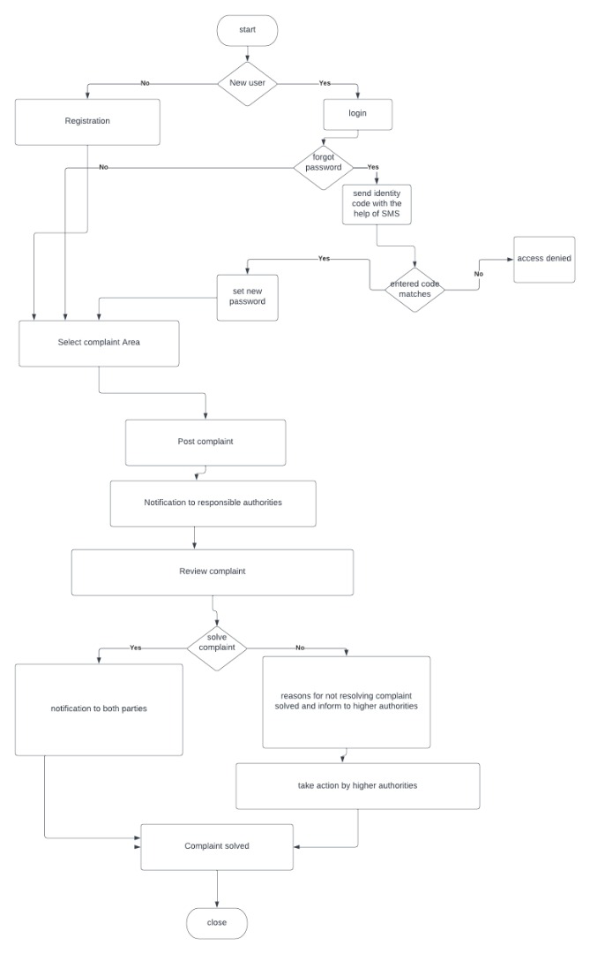

*Figure 3.1 Flow Chart Diagram*

* + 1. **Entity Relationship diagram**

This depicts the relationship between data objects. The attribute of each data object noted in the entity-relationship diagram can be described using a data object description. Data flow diagram serves a purpose:

* To provide an indication of how data are transformed as they move through the system.

**Data objects**

A data object is a representation of almost any composite information that must be understood by the software. By saying composite information, we mean something that has a number of different properties or attributes. A data object encapsulates data only, there is no reference within a data object to operations that act on the data.

**Attributes**

Attributes define the properties of a data object and take on one of three different characteristics. They can be used to:

* Name an instance of data object
* Describe the instance
* Make reference to another instance in other table

Below is a graphical representation of the ER diagram.

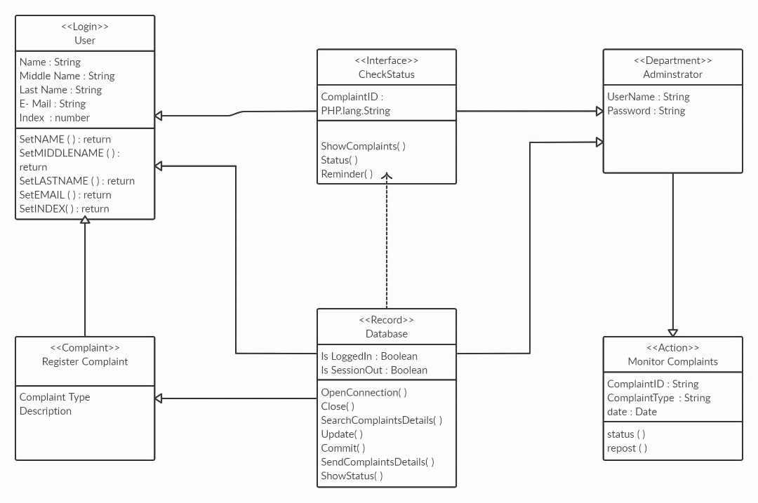

*Figure 3.2 Entity relationship Diagram*

* + 1. 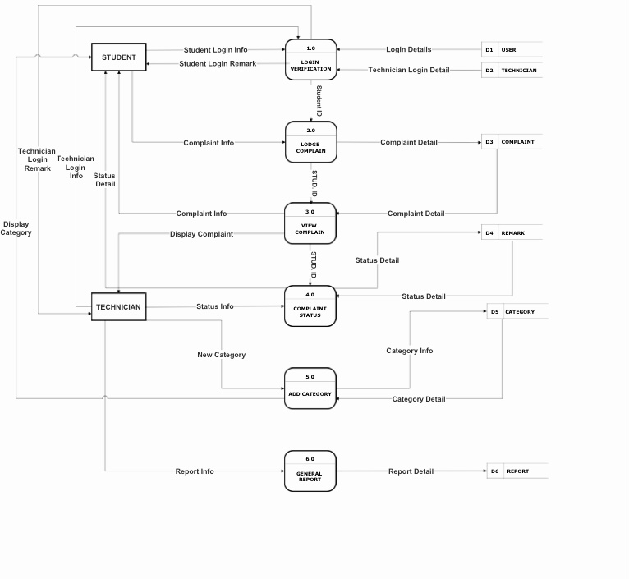**Data flow Diagram**

*Figure 3.3 Data Flow Diagram*

* + 1. **Use case diagram**

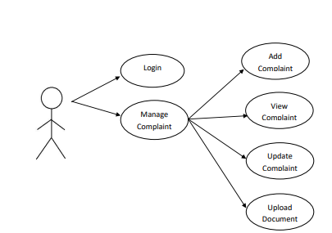

*Figure 3.4 Student module***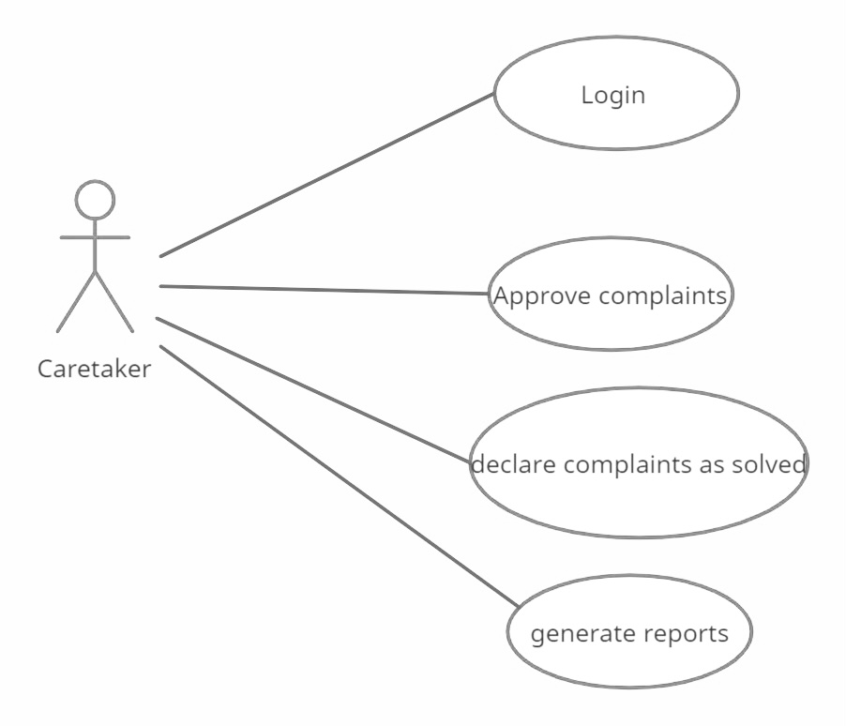**

*Figure 3.5 Care taker module*

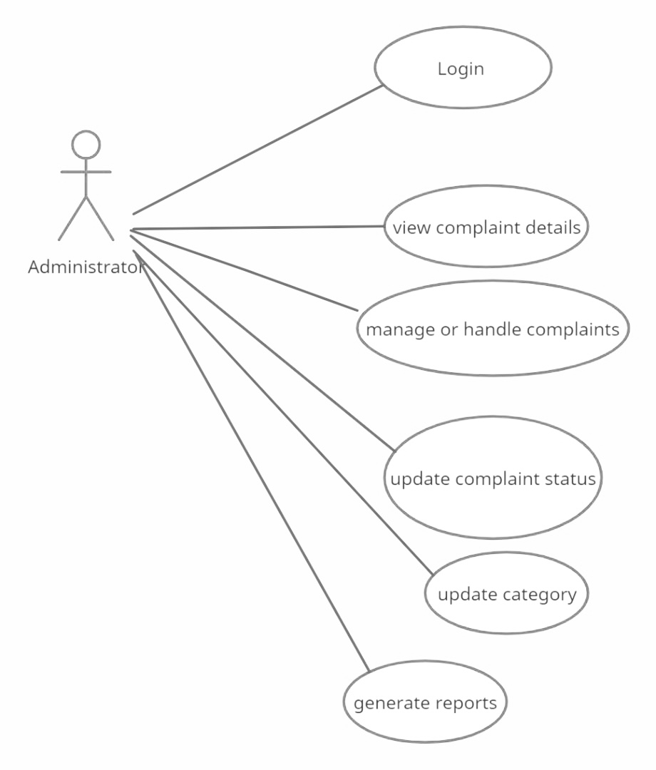

*Figure 3.6 Administrator or Technician module*

* 1. **System development and tools used**

The following programming languages and web technologies will be used;

**HTML (Hypertext Markup Language)**

It is a markup language for structuring and presenting content on the World Wide Web. It is the fifth and current version of the HTML standards. We used HTML to ensure proper formatting of text and images so that the internet browser may display them as they intended to look. Without HTML, a browser would not know how to display text as elements or load images or other elements. HTML also provides a basic structure of the page, upon which Cascading Style Sheets are overlaid to change its appearance.

**PHP (Hypertext Preprocessor)**

It is a server side scripting language designed primarily for web development but also used as a general purpose programming language. In this project the team will use PHP to send information from the browser to the database, thereby making the page dynamic. Basically it will serve as a medium through which the information in the browser will be sent over to the database and vice versa. Typically when a user logs on to the system and uploads complaints, PHP will transport the information into the MySQL database.

**JavaScript**

It is a high level, dynamic and interpreted scripting language that enables us to control the events and actions that will happen on the client side of our application, in this case the system will heavily depend on jQuery JavaScript library to manipulate events and effects of the page such as displaying modals, alerts and other relevant Ajax calls.

**MySQL**

MySQL is a Relational Database Management System that runs as a server providing multi-user access to a number of databases. The SQL phrase stands for Structured Query Language. MySQL will be used to connect the database systems of “UPSAkonnect” complaint management system keeping records of uploaded complaints, administrator accounts, caretaker accounts etc.

**Bootstrap**

It is a free and open source Front-end web framework for designing responsive websites and web applications. It includes HTML and some CSS based designs for typography, forms, buttons, images, modals, and many others, as well as optional JavaScript plugins. The team will use the bootstrap classes in order to make the web page responsive and scalable on all devices.

**NOTE:** In place of writing pure CSS, that is the Cascading Style Sheets, the developer team decided to stick to Bootstrap in order to work best within the project timeline and focus more attention on other sophisticated aspects of the project.

**ARCHITECTURE OF THE SYSTEM**

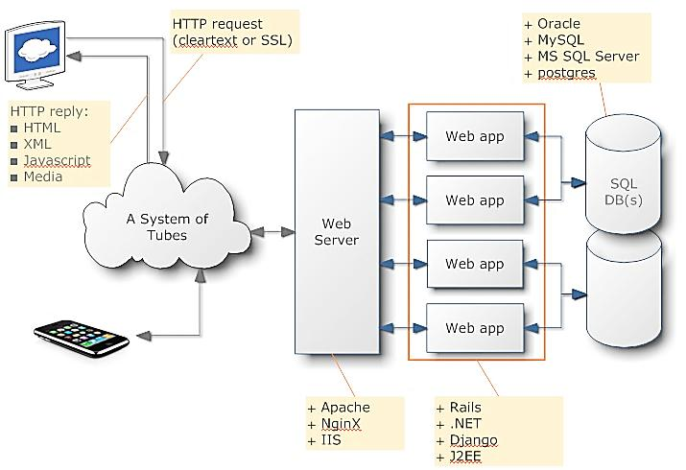

*Figure 3.7 Architecture of The System*

The image explains how information will flow through the various components of the system. The user will log on to the internet through a web browser e.g Chrome, Firefox, safari etc.

The user (student), administrator and the caretaker will enter the web address into the address bar of the browser and hit enter, for example (www.UPSAKonnect.com), this will trigger the web server to load up the web page and al the related files to the browser making the request. The web server actually serves as the link between the browser (user-end), the database and server application (back-end). Typically when a user or student wants to upload a complaint the credentials or information provided by the user will be checked against the existing data in the database or inserted if the student is a new user.

**CHAPTER FOUR**

**SYSTEM TESTING, IMPLEMENTATION AND DOCUMENTATION**

1. **Introduction**

Testing is one of the most essential parts of every software development process. It involves various processes that enable developers to check the strengths and weaknesses of the system and how the system will function under diverse circumstances. A typical testing method is the unit testing, which involves testing every aspect of the system as well as the general testing of the system to ensure that all the components of the system are well unified.

The purpose of testing a system is to check whether there are bugs that need to be debugged to ensure that system works the way it is expected to and also to check if some part of the code has been left out of the system which can probably cause the malfunctioning of the system. In the area of scalability, the ability of the system to integrate successfully with other systems was also looked at in this context.

**Objectives of testing**

* Testing is a process of executing a program with the intent of finding the error.
* A good test case is one that has a high probability of finding an unpredictable error.
* A successful test is one that provides solution for unpredictable error.

The minimum aim of the testing process is to identify all defects existing in software products. Software product testing accomplishes a variety of things, but most importantly it measures the quality of software that is developed. This view presupposes that there are defects in the software waiting to be discovered and this view rarely disapproves or even disputes.

* 1. **Testing of the new system**

In order for “UPSAKonnect” to work fully, the developer team will perform the following tests:

* + 1. **Unit Testing**

It is a software testing method by which individual units of source code, sets of one or more computer program modules together with associated control data, usage procedures and operating procedures are tested to determine whether they are fit for use. (Unit Testing, 2018). It focuses on verifying a small portion of functionality of the system. It is important because this is where each unit of the application is tested by possible input sets to check if the system provides the desired output. We have various units of the system such as the user view, administrator view, caretaker view, database and alert systems etc.

* + 1. **Functional testing**

It is a type of software testing whereby the system is tested against the functional requirements/specifications. Functions or features are tested by feeding them input and examining the output. Functional testing ensures that the requirements are properly satisfied by the application. This type of testing is not concerned with how processing occurs, but rather, with the results of processing. It stimulates actual system usage but does not make any system structure assumptions.

* + 1. **Usability testing**

This can be seen as an irreplaceable usability practice, since it gives direct input on how real users use the system. It focuses on the practice of testing how easy a system is designed to be used by a group of users. It usually involves observing users or customers to complete a task to see whether the system is user friendly and if they are able to find their way around the system easily. This can be seen as an irreplaceable usability practice, since it gives direct input on how real users use the system.

* + 1. **Acceptance testing**

Formal testing with respect to user needs, requirements and business processes conducted to determine whether or not a system satisfies the acceptance criteria and to enable the user, customers or other authorized entity to determine whether or not to accept the system.

* + 1. **Visual testing**

Verifies that the user interface appears correct to its users. Even though you invested many hours to make your application work and wrote tests to prove that your code functions as expected, and even if everything appears to be working on your end, none of that matters if the application is not working properly for your users.

* 1. **Implementation of the new system**

In software development, a crucial aspect is the implementation of the system; this means that the system will not be in use or valued until the process of implementation is accomplished. In view of this, the developed system will take four major implementation methodologies, these are the Pilot, Phased, Direct and Parallel implementation.

* + 1. **Pilot implementation**

This is where the new system is used at a department of an organization to check its efficiency or effectiveness over a period of time before the whole organization adopts it. So the developers and a few number of people will only use the system among themselves for a set period of time to verify the effectiveness before releasing it to the general public.

* + 1. **Phased implementation**

This is the type of implementation whereby the system is introduced in phases or stages in one component at a time until all components of the old system have been replaced with that of a new system. Users will not have full access of the system at the immediate stages of deployment but the development team will release upgrades periodically to add up to the already existing system.

* + 1. **Parallel implementation**

This involves the running of the old system alongside the new system until users have become conversant with the new system after which the new system will be established fully without any issues. “UPSAKonnect” online complaint management system will not totally kick out the old means of lodging complaints but rather run alongside till users fully get comfortable with the online system.

* + 1. **Direct implementation**

With this approach, the system is implemented and tested to ensure it performs properly. Then the old system is removed and the new one put in its place without any overlap or limited roll out. This is a risky strategy as any issues with the new system may have an immediate impact on the day to day activity of the organization. On the other hand it has the advantage of being a fast roll-out compared to the parallel, phased and pilot approaches.

Above are the types of implementation that will be considered in deploying the developed system, we strongly recommend the parallel implementation. The reason is that it will take time for users to fully embrace the new system of lodging complaints.

* 1. **System Documentation**

In this section the developers will delve into all relevant aspects of the system, this includes the graphical interfaces, source code and access levels.

* + 1. **About the system**

As stated earlier “UPSAKonnect” online complaint management system is a web based application that resides on the internet, accessed in web browsers by the students of UPSA. The key focus is given on data security as the project is online and will be transferred in network. The speed and accuracy will be maintained in a proper way.

The system comes in three main sections, which is the administrator dashboard, the caretaker dashboard and the user view. This is hierarchical in the sense that the administrator has many privileges over the caretaker and the user.The administrator manages the caretaker and as well the users. The caretaker takes control of the complaints the users make and also all other relevant activities.

Users will access the web application through a computer that has internet access, allowing them to lodge their complaints.

**Administrator view**

This comes in the form of a dashboard that clearly categorizes all activities and processes ongoing in the system. The dashboard makes it possible for the administrator to:

* List all complaints
* View pending, approved and discarded complaints
* List all feedbacks
* List all caretakers
* Add and delete caretaker

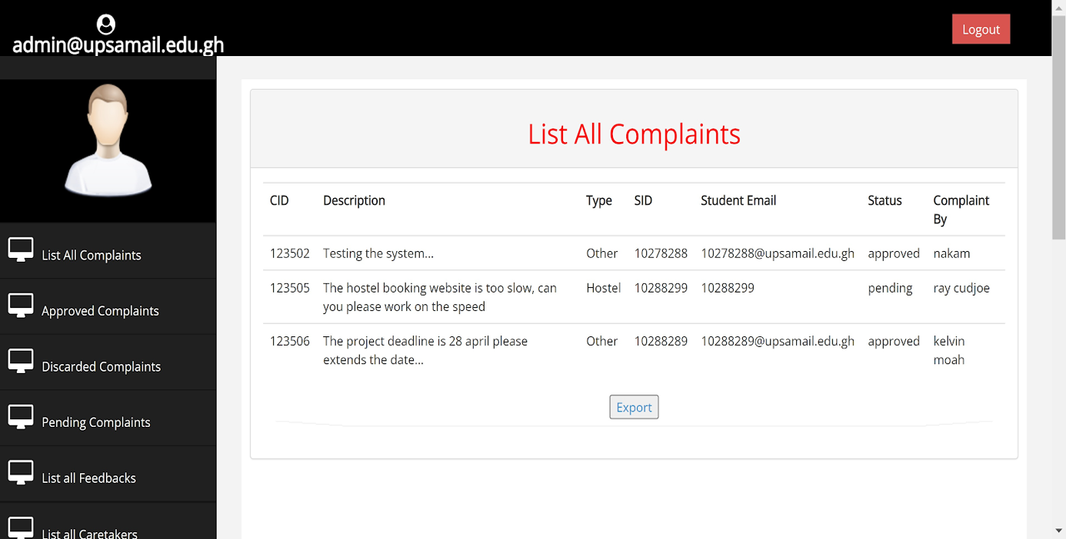

*Figure 4.1 The Administrators View of the System*

* + 1. **User access level**

This is a technique in modern system development where several areas of the system are segmented for particular users, this is to say that the application has several levels of access based on the roles and permissions given to a single user.

User access level is part of an Access Control procedure for computer systems which allows a system administrator to set up a hierarchy of users. That is, the low level users can only access a limited amount of information pertaining to the system whereas the highest level of users can access the most sensitive data on the system. In live business there are transactions and operations which should not be controlled by customers.

In this web based complaint management system three major entities play important roles and therefore have different access levels, that is, the administrator, the caretaker and the general user (student). Administrator has the privileges of deleting an account, disabling user accounts, view overall user statistics, viewing full correct information of users while the user is limited to accessing and performing operations like lodging complaints and editing their complaints and changing the account settings.

* + 1. **Getting started**

The developers used a simple approach and interface in order for users to get most out of the system, below are images of the interfaces also attached in the database structure and table relationships.

**Homepage**

This is the landing page for all users when they access the webpage. Users can register or sign in through available links on the page.

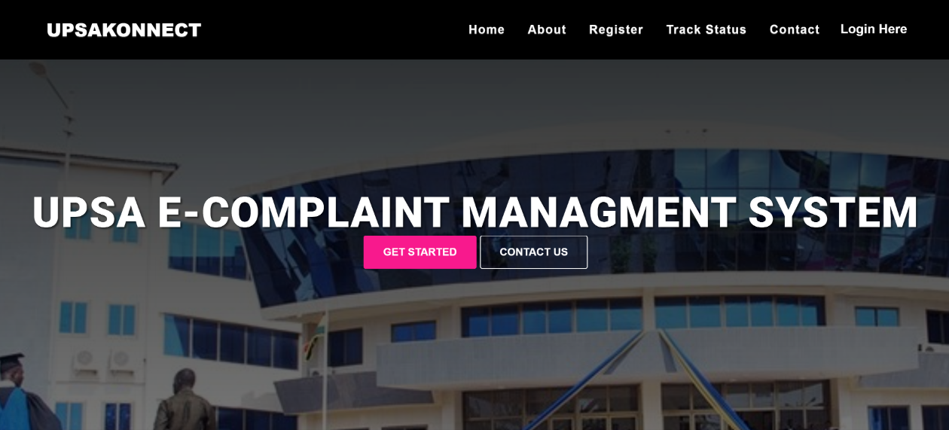

*Figure 4.2 The System Homepage*

**Log in/ Register**

The register button allows new users to sign up onto the system and be able to post properties while the sign in button allows already existing users to sign in to the system and manage their accounts. These two operations come with a similar interface, which is they use a bootstrap modal to display a popup for users to perform their actions instead of redirecting users to an entirely different page for them to perform these operations.

**Login modal**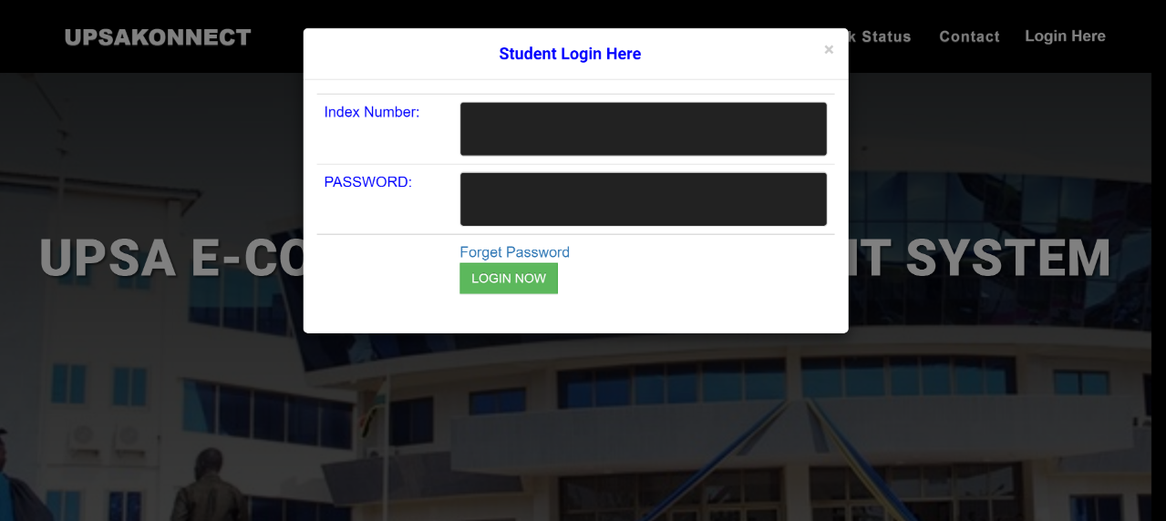

*Figure 4.3 Student Login Modal*

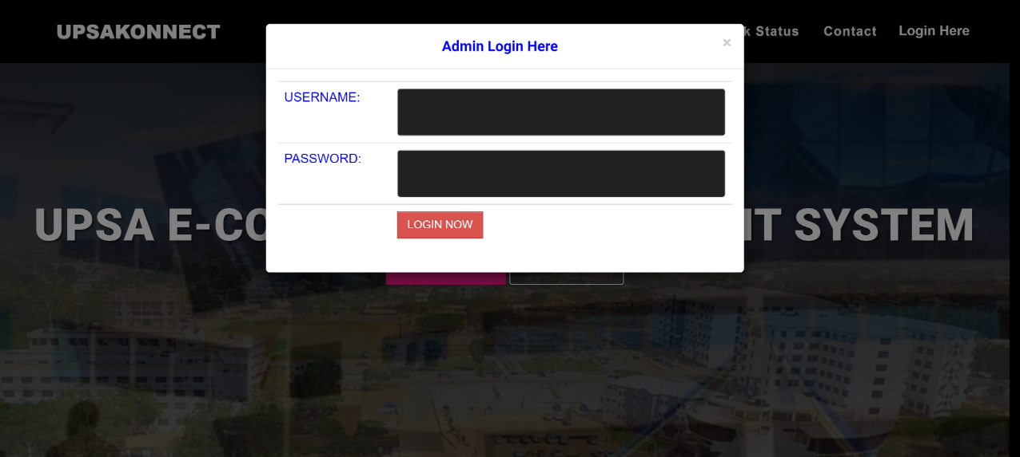

*Figure 4.4 Administrator Login Modal*

**Registration modal**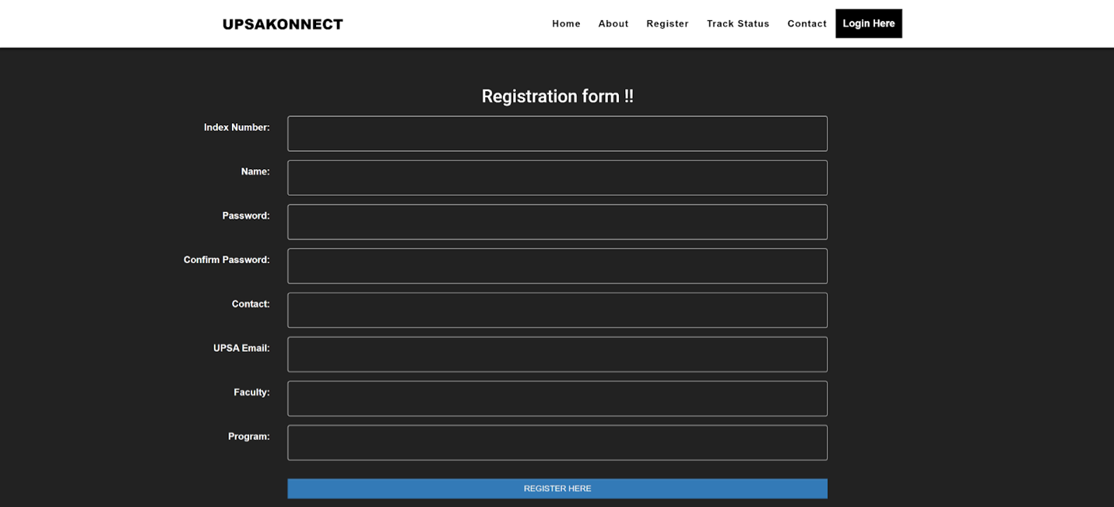

*Figure 4.5 Registration Modal*

**Complaint upload page**

This form provides the user with an interface to state his or her grievances for it to be solved by the administrator.

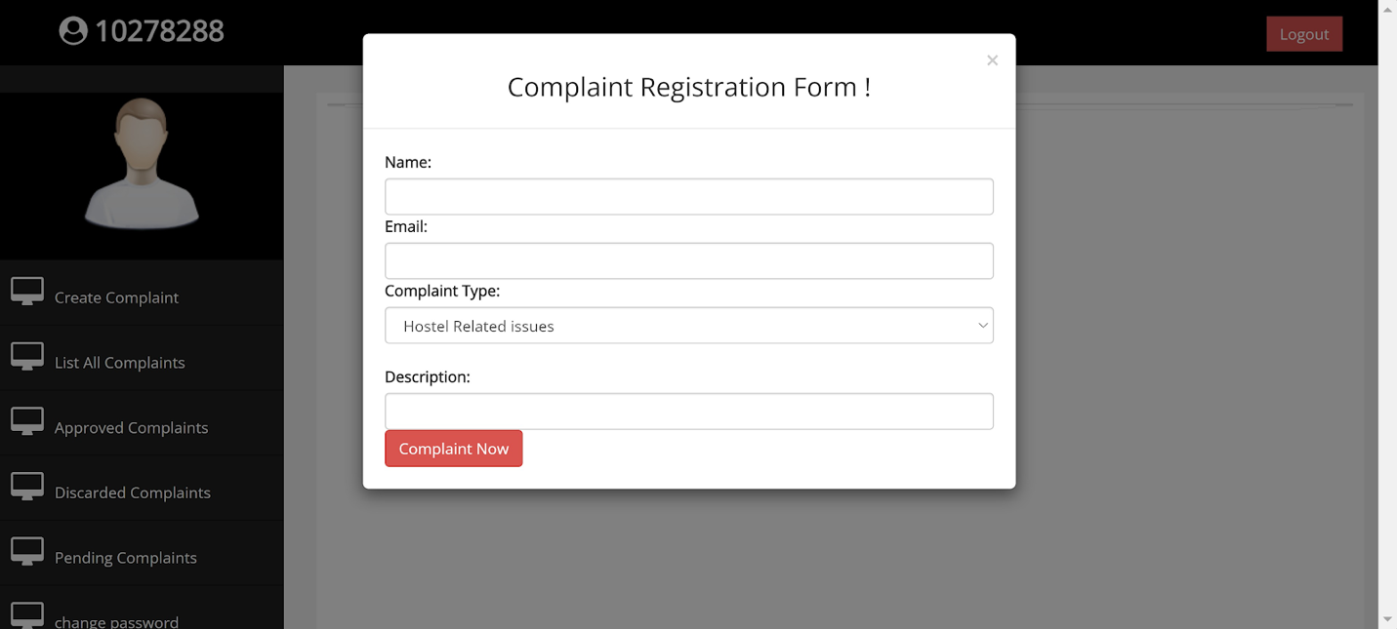

*Figure 4.6 The Complaint Upload Page*

* 1. **Conclusion**

UPSAKonnect complaint management system comes in very handy for all individuals who would like to make their grievances known. This system has been computed successfully and was also tested successfully by taking “test cases”. It is user friendly, and has required options, which can be utilized by the user to perform the desired operations. The system has been designed keeping in view the present and future requirements in mind and very flexible. The goals that are achieved by the software are instant access. Improved productivity, optimum utilization of resources, efficient management of records, simplification of the operations, less processing time and getting required information.

**CHAPTER FIVE**

**CONCLUSION AND RECOMMENDATION**

1. **Introduction**

This chapter basically is all about what we as partners have encountered and learnt during the course of our project work and a few recommendations to aid project improvement. Above all, it is clearly stated that technology is taking place in everything. One of the advantages of technology is that it saves time and gives one the benefits of the new era. The traditional ways of doing things are rapidly fading away. Technology is dominating human life with the emergence of powerful software and technological devices by which extra work for mankind is reduced and even avoided.

* 1. **Summary**

UPSAKonnect being it the system designed is by far one of the best institution boosting systems yet to be implemented and with the right approach and technology the University of Professional Studies Accra will be able to make easier the current complaint management system. This will be through enabling students or customers to file their complaints from the comfort of their homes or anywhere through their devices with the help of the internet. Basically the designed system can be operated by any individual with a device which is able to connect or access the internet. The system does not also require any amount of skill before the user can operate it. The introduced system has been tested to accept, monitor, track and keep records of complaints submitted.

* 1. **Recommendations**

Due to some basic confrontations of the complaint management system the developer team would recommend that the institution;

* Educate the staff and students about the introduction of the new system: This can be done in several forms to educate them, these are radio & television advertisement, personal interaction which could also be visiting them in their classes or offices, organizing seminars and workshops to educate the students and staff of the institution.
* Employing system administrators: The system needs real time monitoring and this should not be done by regular staff of the institution. The developers recommend that the organization employs an individual who is much knowledgeable in computing systems to make it much easier to monitor, respond to users’ complaints, approving of uploaded data and other operations in the system.
* Acquire active Internet Access: Since the system is a web based system administrators will need internet connection to access the data on the system and also students will need the internet to access the system implemented to submit their complaints and also track and check responses.
  1. **Conclusion**

To conclude, the system is being built to help ease and speed up the existing complaint management system to eliminate or reduce the problems faced by the institution in dealing with student and staff complaints. The proposed complaint management system is to improve upon the existing complaint management system, and currently the system has been developed successfully. We extend thanks and appreciation to everyone who helped and supported us to complete this project with immense success.

From our hearts we express our sincere gratitude and big thanks to our esteemed project supervisor Dr. Patrick Kudjo for the patient guidance, encouragement and advice through out the course of our project work, without which this project work would not have been successful. The process of this project has been quite demanding but we have been able to learn a whole lot which have improved our knowledge and ability to deal with systems both theoretically and practical wise.

**REFERENCES**

Karande, K., Magnini, V.P. and Tam, L. (2007) Recovery voice and satisfaction after service

failure: An experimental investigation of mediating and moderating factors. Journal of Service Research 10 (2): 187– 203. Retrieved from;

<https://journals.sagepub.com/doi/10.1177/1094670507309607>

Doyle, M. & Straus D. (1976). How to Handle Complaint Better: The new interaction method.

Chicago: Playboy Press.

(1999).i-Sight Service and Complaint Management Software. Retrieved from:

<http://www.customerexpressions.com/cex/cexweb.nsf/(GetPages)/6362FC56F53DB37185256FE8004F508B>.

Yang, Y. and Pedersen, J., (1997). A Comparative Study On Feature Selection In Text

Categorization. Proc. 14th Int’l Conf. Machine Learning, 413, p.420. Retrieved from:

<http://nyc.lti.cs.cmu.edu/yiming/Publications/yang-icml97.pdf>

Work pro. (2011). Complaints Management System. Retrieved from:

<http://www.workpro.com/complaints-management-system>.

Jingjing Tao; Xi Chen; , "Web Service Based Enterprise Mobile Information System,"

Multimedia Information Networking and Security (MINES), 2010 International Conference on, vol., no., pp.320-323, 4-6 Nov. 2010 doi: 10.1109/MINES.2010.216

from: <http://ieeexplore.ieee.org/stamp/stamp.jsp?tp=&arnumber=5670833&isnumber=5670801>

Sridhar, R. P.,Sangareddy, Sanjeev, J., Chen, Y., Kevin, C. P. (2009). Attaining superior complaint

resolution. Communication of the ACM; A View of Parallel Computing. 52 (10), October 2009, 122-126. Doi: 10.1145/1562764.1562795

Lewis, D., 1992. Feature Selection And Feature Extraction For Text Categorization. Journal of

Computer Applications, (7), pp.212-217..

Stauss, B. and Schoeler, A. (2004) Complaint management profitability: What do complaint

managers know? Managing Service Quality 14 (2/3): 147–156

Baeza-Yates, Ricardo & Ribeiro-Neto, Berthier. (1999). Modern Information Retrieval.

Retrieved from:

<https://www.researchgate.net/publication/2352627_Modern_Information_Retrieval>

Coan, J., 2022. Customers Complaint Management- Aberdeen Strategy & Research.[online]

Aberdeen Strategy & Research. Available at:

http://www.aberdeen.com/_aberdeen/app/research- agenda/library.aspx

**APPENDIX A**